Abstract

For over 15 years Games World provides with unique opportunity to all gamers around the world to download and play 5000+ games at fair prices.

**Created By**

**Akil Adnan Bhuiyan**

**Fahim Ahmed**

**Taharam Chowdhury**

**Lamyea Hoque**

Games World

Online Games Store

Games World

“Games World”” is an online games store which sells latest and old PC games. All our downloadable games are full version with secure downloads, no trial periods and no ads. Download as many games as you want play as long as you want, you will be never charged for anything.

"There is no way to succeed in business without the highest ethical standards"

– Jordan Belfort.

As an online business, very important thing here we follows is the **transparency**. To make a good bond between company and client, we have provided the company profile regarding the 5 years of history. And also, the company contact details.

Well use of well secured internal system to improve the **integrity** of the data and calculations for the items and prices for the orders. Websites **secure the customer data** by applying the techniques and make lawful interconnection.

We are providing PC games above +5 years old ages who owned computers and people who sell PC games locally and the people who owned game cafes.

We provide latest and old pc games which people loves to play. And we allow them to buy the Full Version of the game. The activation for the game will be available for any number of users and for lifetime. In future we will allow them to have good discounts and offers.

There is nothing deep to research regarding the gaming field. But the customer needs to have a look around the system requirements which required for each game. They need to check their computer has enough performance to run the game.

Targeted users have good knowledge around the gaming field. Computer games are something that many people do as a hobby since several decades.



The prices of the games can be changed according to the time. And new games can be released each and every day. So, the customers need to be updated regarding that.

If they wish to buy a game, they can search more regarding the game in the official site of the particular game. Game story, System requirements, Credits, View of the game and etc. are the information that users have to discover as they needed.

Video Game Companies

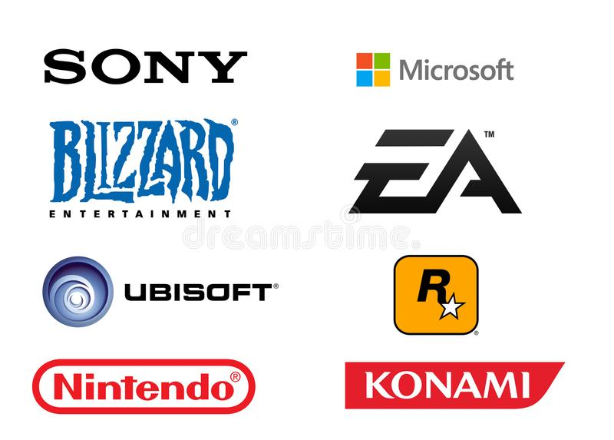

Our site has provided Email, Contact Number, Address, and map locations. Customers can contact the company anytime within Monday to Saturday from 8.00 am – 8.00 pm. Or make an appointment through an email to meet our team.

This is a field which close to the people since the Personal Computer invented. So, there is no any effort need to make it familiar for our clients.

As a product, each game has unique information. So, the customer needs to have a look around the product before they buy.

Customer can add games into cart and check the cart and provide contact information. Then they can get the download link for the game to their provided email address.

Hierarchy of the website

HOME

Check Out

Products

Find Us

Gallery

Many sites provide free versions of the games, and we need to make the payment separately. Here we provide them online payment and they can directly download the paid full version easily.

[www.gametop.com](https://www.gametop.com/) is also a website which provide pc games to download. But most of their games are free versions that less quality and value. They also have around 1000+ of games in their collection. The company has started before 10 years.

Their wireframe was following

The people who interested in the gaming field are very much familiar to ask the next versions of the game in our website. And they are also familiar to ask the new versions of the old games thru “Contact” that they have played in their childhood.

---------

**Questions regarding the projects:**

**a. what is your business:** We are providing PC games above +5 years old ages who owned computers and people who sell PC games locally and people who owned game cafes.

**b.what is the business ethos:** We provide the latest and old pc games which people love to play. And we allow them to buy the Full Version of the game. The activation for the game will be available for any number of users and for a lifetime. In future, we will allow them to have good discounts and offers.

**c.what do you produce/make/offer/sell:** There is nothing deep to research regarding the gaming field. But the customer needs to have a look around the system requirements required for each game. They need to check their computer has enough performance to run the game.

**d.who is your target audience:** Targeted users have good knowledge of the gaming field. Computer games are something that many people do as a hobby for several decades.

**e.what are the key motivations of why you expect people to visit your website and how you will attract and motivate people therein:** As an online business, a very important thing here we follow is transparency. To make a good bond between the company and the client, we have provided the company profile regarding the 5 years of history. And also, the company contact details.

**f.do they want general information/research (such as background on a topic/company), or are they after something specific:** Well use of the well-secured internal system to improve the integrity of the data and calculations for the items and prices for the orders? Websites secure customer data by applying techniques and making lawful interconnections.

**g.are they already familiar with the service or product that you offer or do they need to be introduced to it: ​​**This is a field that is close to people since the Personal Computer was invented. So, there is no effort needed to make it familiar to our clients.

**h. are they looking for time-sensitive information, such as the latest news or updates on a particular topic:** As a product, each game has unique information. So, the customer needs to have a look around the product before they buy.

**i. do they want to discover information about a specific product or service to help them decide whether to buy it or not?** The prices of the games can be changed according to the time. And new games can be released each and every day. So, the customers need to be updated regarding that.

**j.do they need to contact you? If so, can they visit in person (which might require opening hours and a map)? Or might they need email or telephone contact details?**

Our site has provided Email, Contact Number, Address, and map locations. Customers can contact the company anytime from Monday to Saturday from 8.00 am – 8.00 pm. Or make an appointment through an email to meet our team.

**k. will visitors be familiar with your subject area/brand or do you need to introduce yourself?** If they wish to buy a game, they can search more regarding the game on the official site of the particular game. Game story, System requirements, Credits, View of the game and etc. are the information that users have to discover as they needed.

**l. will they be familiar with the product/service / information you are covering or do they need background information on it?** Customers can add games to their cart and check the cart and provide contact information. Then they can get the download link for the game to their provided email address.

**m. what are the most important features of what you are offering?**  We are providing recreational games that make users more creative. “Games World” is an online games store that sells the latest and old PC games. All our downloadable games are full versions with secure downloads, no trial periods, and no ads. Download as many games as you want and play as long as you want, you will be never charged for anything.

n. **what is special about what you offer that differentiates you from other sites that offer something similar:** Many sites provide free versions of the games, and we need to make the payment separately. Here we provide them with online payment and they can directly download the paid full version easily.

**o. once people have achieved the goal that sent them to your site, are there common questions people ask about this subject area:** The people who are interested in the gaming field are very much familiar to ask about the next versions of the game. And they are also familiar to ask the new versions of the old games that they played in their childhood.